Software Design Document

**Malaria Android**

Peace Corps & Systers

By:- Ankita Kalra

[ankita.kalra30@gmail.com](mailto:ankita.kalra30@gmail.com)

[Systers Dev Profile](http://systers.org/systers-dev/doku.php/ankita_kalra)

|  |  |
| --- | --- |
| **Index** | |
| 1. | Introduction |
| 2. | System Overview |
| 3. | Component Design |
| 4. | Data Design |
| 5. | User Interface Design |
| 6. | Application Flow Diagram |
| 7. | Unit Test Cases |
| 8. | Future Prospects |
| 9. | Useful Links |

1. **Introduction**

**1.1 Purpose of Document**

This software design document aims at explaining the architecture and design of Malaria Android Application. This document gives an insight to the functional description of each of the modules in system. Also, it elucidates the technologies used in the application as well as choices made for them. Additionally, this document explains the implementation of each of the functionalities in the module.

**1.2 Overview of Document**

In following subsections, this document will provide us with an overall description of the system. Also, it will explain architecture of the system, which will mention the purpose of each of the functional modules involved and ideologies behind it.

Further, this document will clearly explain how the functional modules were implemented, also the technical decisions which were made in choosing them. Additionally this document will explain the data model of the database, variable descriptions and fields present in Shared Preferences, and also the files used to stored data as Cache.

Screenshots present in Human User Interface Section provides us with visual of the application for clearer understanding. Diagrams are used in this document to make the understanding of data model, application flow and deployment even easier.

This document also contains the JUnit Test Cases, and Android Test Cases used as well as results. Important links are also included in the document which are related to the project, such as Requirements Document, Source Code etc.

**2. System Overview**

**2.1 Aim of Application**

As quoted in the [Malaria Application Requirements Document v5](https://github.com/PeaceCorps/malaria-app-readme/blob/master/Malaria Medication Mobile App Requirements v5.docx)-

“This mobile application is to help volunteers sustain protective practices against malaria. The two main features will include a reminder system to help volunteers take their medication on schedule, and also act as an information hub to get accurate information about the real risks associated with malaria and the practices used to avoid it.”

**2.2 Overview of Features in Application**

Peace Corps is looking to build a mobile app that will aid the Volunteer in sustaining life-saving malaria prevention tactics over their 2+ years of service. Prevention is focused on sustained use of preventive medications, which are taken . Since, Peace Corps is looking to build a mobile app that will aid the Volunteer in sustaining life-saving malaria prevention tactics, this application is focussed on sustained use of preventive medications , which are taken and also taking necessary precautions.

This application features three main components:-

i) Medicine Reminder System

It is an alarm notification facility which reminds user to take the medication at stipulated time, also indicates if the user has missed the medication.

ii) Pill Tracker Analytics

It enables effective tracking and management of medication in terms of it’s usage and adherence. It does the analysis by using graphs, adherence rate as a parameter and progress bar.

iii) Info Hub

This facility keeps the user updated about the latest happening related to Malaria in terms of policies, side-effects and effectiveness against the disease.

iv) Trip Indicator

This facility helps remind volunteers to pack certain supplies to prevent malaria if they leave their home village.

**3. Component Design**

**3.1 Functional Description of Components Involved**

**3.1.1 Setup Screen**

1.Set-up screen includes drop down menu allowing user to select one of the 3 medications Peace Corps provides:

1. Doxycycline
2. Malarone
3. Mefloquine

2. Set-up screen allows user to set the time of day a reminder will come as an alert dialog or as a post on notification bar.

3. Tapping on Pick Time text box opens a time picker, user can select desired time of reminder form it.

4. Done button is not enabled until the user selects the reminding time of medication. Once the user selects it, done button is enabled.

5. Clicking on Done leads to the Home Screen.

6. The only way to refresh it, is clicking on the gear icon on the top of screen.

7. If the setup screen is re-opened and the details are modified, then application will behave same as that for fresh install.

**3.1.2 Home Screen**

1. There are 3 primary navigation icons at the bottom of every screen in the application. For the medicine tracking and analytics screen, the first icon, the hut, is selected.

2. The name of the day appears at the top of the screen, with the date smaller and below it.

3. The gear icon in the upper right will take you to the set up screen.

4. There are two buttons to indicate if the user took the medication or not, a red X and a green Check.

5. If the user clicks one of the buttons, the color of the selected button changes slightly to indicate it has been selected. The other button will lose its color and become gray-scaled. For example, if I press the check mark, the X will become greyed out and the Check symbol will become a more vibrant green color.

6. Clicking each button will also trigger a unique sound file to play. The sound file will be a pleasing sound if the user took the medication and a negative sound if the X mark was selected.

7. If a user misses a day, and their medication should be taken daily, the application will record the missed day as a missed X data point.

**3.1.3 Pill Tracker First Analytic Screen**

1. One can navigate to this screen by sliding home screen towards the left.

2. It shows three main data points:-

a. Medicine Last Taken: Displays the date the user last recorded that they took medication.

b. Doses in a Row (Mock up shows different value): Shows the number of times the user correctly recorded the medicine in a row. Missing a day/week will reset this count.

c. Adherence to Medicine: This is the adherence to the medicine schedule to the entire time the user has been using the application, (# of doses taken)/(# of doses that should have been taken).

**3.1.4 Pill Tracker Second Analytic Screen**

1. If a user swipes to the screen right from the first Pill Analytics screen, accesses a Second Screen of Analytics.

2. The user will see their adherence percentage by month, with each of the most recent four months depicted as progress bars, including the current month. (# of doses taken)/(# of doses that should have been taken).

3. Each Month Progress Bar is clickable, and takes the user to a calendar view of that month.

**3.1.5 Pill Tracker Third Analytic Screen**

1. Clicking on a Month Progress Bar, takes the user to a calendar view of that month.

2. Each gridcell has a tiny green check mark, if the medication was taken, and a tiny red X point, if the medication was not taken.

3. Grey gridcells are used to indicate if no data is present in the database corresponding to the day.

4. Clicking on each gridcell opens the corresponding the Day Analytic Screen.

**3.1.6 Pill Tracker Day Analytic Screen**

1. Day Analytic Screen consists of two fields-

a. Drug: Name of the Drug Taken

b. Taken or Not : Green Check Icon if medication was taken, Red X point if medication was not taken. Grey tick, if no data was entered.

2. It has a red edit button at the bottom right of the screen, clicking upon which opens a dialog fragment showing instructions to edit whether medication was taken on that specific day or not.

**3.1.7 Info Hub Screen**

1. The Info Hub is accessed by clicking on the “i” icon in the bottom navigation tray.
2. The hub features 6 buttons that link to 6 pages of information as follows-

o Peace Corps Policy

o Percentage of Side Effects

o Side Effects Reported by PCVs

o Effectiveness Against Malaria

o Volunteer Adherence Rates

o Non-PCV Reported Side Effects

1. Clicking on any of the buttons leads to the corresponding activity.
2. If internet connection is available, the data is fetched from <http://pc-web-dev.syster.org/api/posts/?format=json>
3. If no internet connection is available, the data is fetched from Cache directory.

**4. Data Design**

**4.1 Database Description**

**Database Name-** DATABASE_NAME=”MalariaDatabase”

**Table Name-** userMedicationChoiceTable=”userSettings”

|  |  |  |  |
| --- | --- | --- | --- |
| **Field Name** | **Data Type** | **Description** | **Example** |
| Drug | INTEGER | Stores Name of the Drug | Malarone |
| Choice | VARCHAR | Stores User Medication Choice | daily |
| Month | VARCHAR | Stores the month in format MM | 11 |
| Year | VARCHAR | Stores the year in format YYYY | 2015 |
| Status | VARCHAR | Stores “yes” if medication was taken and “no” if it was not taken | yes |
| Date | INTEGER | Stores the date number of Medication Taken | 2 |
| Percentage | DOUBLE | Stores Adherence Rate of User till Date | 76.0987 |
| Timestamp | VARCHAR | Store Date in YYYY-MM-DD format to query data in ascending of date. | 2015-11-2 |

**4.2 Database Implementation**

SQLite Database is used for the implementation of Malaria Database. In the source code, refer to the DatabaseSQLiteHelper.java for the methods related to access of database.

Database basically stores the date of medication, whether the medication was weekly or daily and status of the user if he or she has taken it or not. Purpose of the methods used in the specified file are listed below:-

**4.2.1 Methods**

|  |
| --- |
| **public int getData(int month, int year, String choice)** |

**1.Used for retrieving data in ascending order of date for plotting in the Graph View.**

|  |
| --- |
| **public void getUserMedicationSelection(Context context, String choice, Date date, String status, Double percentage)** |

**2.Used for storing data in the database table as the user enters from the Home Screen.**

|  |
| --- |
| **public String getMedicationData(int date,int month, int year)** |

**3.Used for retrieving data from the database when called day page of each calendar grid cell is called.**

|  |
| --- |
| **public void updateMedicationEntry(int date, int month, int year, String entry,double percentage)** |

**4.Used for modifying the existing medication entry.**

|  |
| --- |
| **public void insertOrUpdateMissedMedicationEntry(int date, int month, int year,double percentage)** |

**5.Used for inserting or updating missed medication in the database.**

|  |
| --- |
| **public int isEntered(int date,int month, int year)** |

**6.Used for stylizing the calendar by green checks and red X by querying the database for medication of each day grid cell.**

|  |
| --- |
| **public long getFirstTime()** |

**7.If the user has modified entry in the calendar, it will scan the database and update the first time medication was taken.**

|  |
| --- |
| **public String getStatus(int date,int month,int year)** |

**8.It is a simple method to know the status i.e. yes or no by querying with date , month and year.**

**4.2.2 Data Structure**

|  |  |
| --- | --- |
| **public static ArrayList<Double> *percentage*;** | **Used for storing and displaying Adherence Rate** |
| **public static ArrayList<Integer> *date*;** | **Used for storing and displaying Date** |

**4.2 Shared Preferences Description**

Fields are stored as com.peacecorps.malaria.field_name in Shared Preferences of Android Device.

|  |  |  |  |
| --- | --- | --- | --- |
| **Field Name** | **Data Type** | **Description** | **Example** |
| hasUserSetPreference | BOOLEAN | True if user has set preferences | true |
| drugPicked | STRING | Stores Name of the Drug | Malarone |
| drug | INTEGER | Stores 0,1,2 for Malarone, Doxycycline and Mefloquine respectively | 0 |
| isFirstRun | BOOLEAN | True if it is first time user is running application | daily |
| firstRunTime | LONG | Stores time when medication was first entered in ms | 1110878373992 |
| AlarmHour | INTEGER | Hour for Ringing Alarm | 12 |
| AlarmMinute | INTEGER | Minute for Ringing Alarm | 24 |
| storeTimePicked | LONG | Stores the time chosen by time picker in ms | 1891382892920 |
| isWeekly | BOOLEAN | If drug is weekly, it stores the true else false | true |
| weeklyDate | LONG | Stores date of weekly medication in ms. | 1872198017011 |
| weeklyDose | INTEGER | If drug is weekly it stores the count of weekly dose. | 3 |
| dailyDose | INTEGER | If drug is daily it stores the count of daily dose. | 3 |
| dayTakingDrug | INTEGER | Stores the day number of Medication Taken (from 1-7) | 1 |
| isDrugTaken | BOOLEAN | True if drug is taken and False if not taken | true |
| checkMediLastTakenTime | LONG | Store Date of Last Medication taken in ms. | 1873017301982 |
| drugAcceptedCount | INTEGER | Total number of drugs taken | 2 |

**4.3 Cache Directory Description**

**4.3.1 Explanation**

When the user clicks on any one of the six buttons in the Infohub and internet connection is not present then the data is loaded from the cache directory. Cache is used instead of Shared Preferences and Database because if the mobile is facing issues of low space then this application won’t prove to be a burden on mobile device. This cache data can be deleted. Everytime the user clicks on any one of the six buttons of Info Hub, the application first checks for internet connection loads JSON Data and incase of any exception loads data from the cache. Once the the updated JSON Data is loaded, it is updated in the cache. So that for offline use, user has the most recent updated cache data.

**4.3.2 Writing to cache file**

**FileOutputStream outputStream;**

**try {**

**file = new File(getCacheDir(), "ECache");**

**outputStream = new FileOutputStream(file);**

**outputStream.write(content.getBytes());**

**outputStream.close();**

**} catch (IOException e) {**

**e.printStackTrace();**

**}**

**4.3.3 Reading from Cache File**

**BufferedReader input = null;**

**File file = null;**

**try {**

**file = new File(getCacheDir(), "ECache");**

**input = new BufferedReader(new InputStreamReader(new FileInputStream(file)));**

**String line;**

**StringBuffer buffer = new StringBuffer();**

**while ((line = input.readLine()) != null) {**

**buffer.append(line);**

**}**

**mEffectivenessLabel.setText(buffer.toString());**

**Log.*d*(*TAGE*, buffer.toString());**

**} catch (IOException e) {**

**e.printStackTrace();**

**}**

**4.3.4 Cache File Description**

|  |  |
| --- | --- |
| **File Name** | **Description** |
| PCPCache | Peace Corps Policy Cache |
| PSECache | Percentage Side-Effects Cache |
| SEPCache | Side-Effects of PCV Cache |
| SENCache | Side-Effects of Non-PCV Cache |
| VACacheIn | Volunteer Adherence Rates Cache |
| ECache | Effectiveness Cache |

**5. Human User Interface Design**

**5.1 Setup Screen**

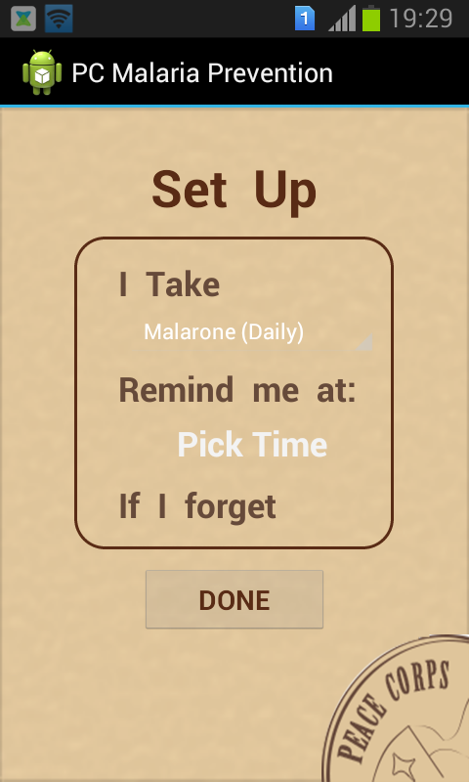

**5.2 Home Screen 5.3 First Analytic Screen**

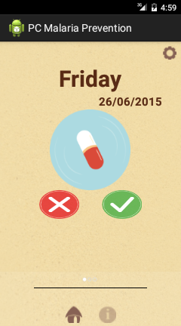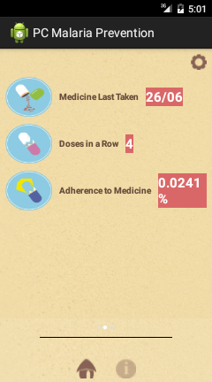

**5.4 Second Analytic Screen 5.5 Third Analytic Screen**

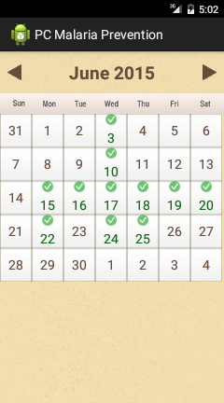

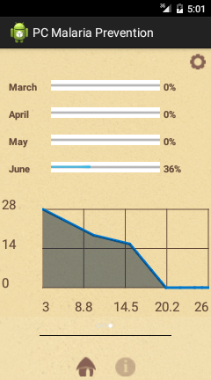

**5.6 Day Analytic Screen 1 5.7 Day Analytic Screen 2**

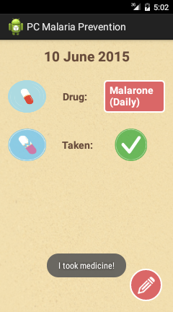

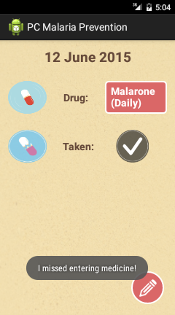

**5.8 Day Analytic Screen 3 5.9 Day Analytic Screen 4**

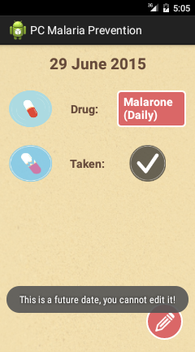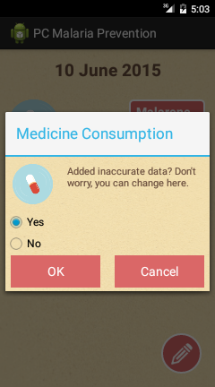

**5.10 Info Hub Screen 1 5.11 Info Hub Screen 2**

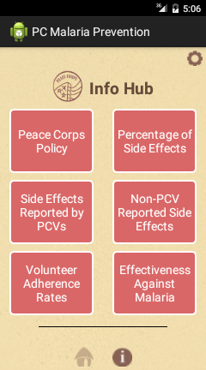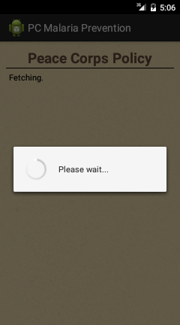

**5.12 Info Hub Screen 3 5.13 Info Hub Screen 4**

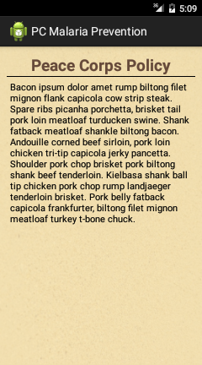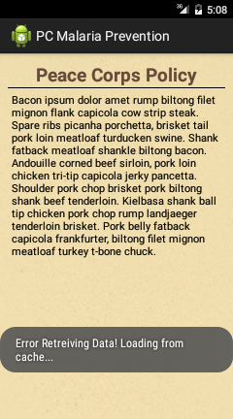

**5.14 Trip Indicator**

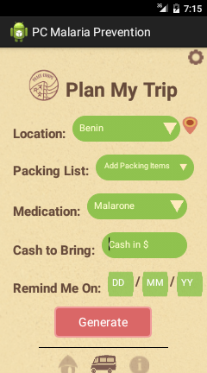

**6. Application Flow Diagram**

**7. JUnit Test Cases**

**8. Future Prospects**

As mentioned in the [Peace Corps Requirements Document v5](https://github.com/PeaceCorps/malaria-app-readme/blob/master/Malaria Medication Mobile App Requirements v5.docx), the future prospects of this app are:-

1. Enhance the web backend with additional features and functionality.

o Enhance the web backend to not only push data down to users for the info Hub, but to also collect and aggregate data from devices to determine compliance metrics for Peace Corps Staff in Country and HQ.

o An enhanced web backend that’s collecting user data could also push down those metrics back to the end user, allowing them to see country-level metrics about how well their peers are doing taking their malaria medication. (Think game-fication)

o Add additional field to the set up screen to track the users gender, age, location, email, and phone.

2. Game-ify the application by rewarding the user with points for staying on track with their medication. Points could be used to redeem virtual or real prize incentives. Actions that earn points could be extended to other sections of the application, like reading all of the info Hub material. Game-ification would allow users to compete against one another as well.

o Every day you’re covered by malaria medication you earn 1 point. Streaks of compliance could act as a points multiplier.

o Allow users to share on social media their malaria medication compliance statistics, or the points they’ve earned through game-ification within the application.

3. Allow the application to keep track of the amount of medication the user has on hand. The application could alert the user when they are going to run out of medication, and potentially connect to a system to order a refill of the medication.

4. Create an Admin version of the app that would allow a staff member in country or in the US to view medicine adherence metrics at a continent, country, or village level, on a mobile device.

**9. Useful Links**

**Link to the source code :-**

<https://github.com/systers/malaria-app-android/tree/ankita-gsoc-v1>

**Link to the requirement doc:-**

[https://github.com/PeaceCorps/malaria-app-readme/blob/master/Malaria%20Medication%20Mobile%20App%20Requirements%20v5.docx](https://github.com/PeaceCorps/malaria-app-readme/blob/master/Malaria Medication Mobile App Requirements v5.docx)

**Malaria Prevention Application**

(cont. Under GSoC 16)

Functional Description of Components Added

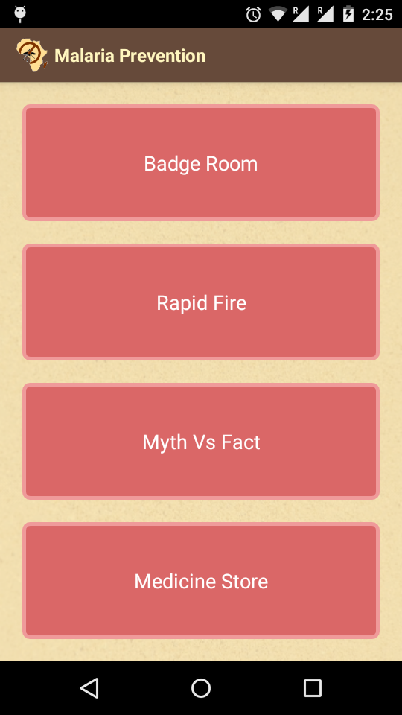

**1. Home Screen**

This screen will provide buttons all the added components such as achievement screen , mini games, user's profile page, medication alert and ordering platform.

It is currently under construction.

**2. Achievement Room**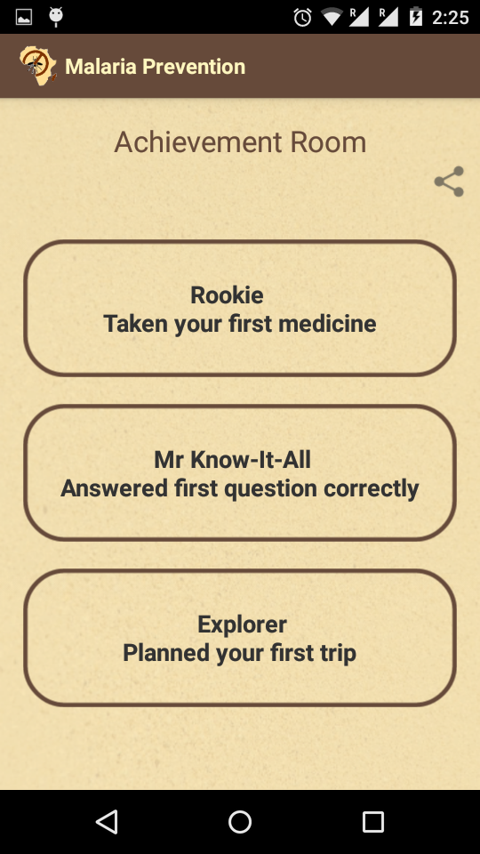

* This is the place where the user can view his/her achievements.
* Achievements are based on 3 categories:

1. Taking medicines regularly.
2. Gaining information about malaria from info hub.
3. Planning trips carefully.

* Different categories of achievements have their own rewards.
* Clicking on each category displays its correspoding rewards

as shown below.

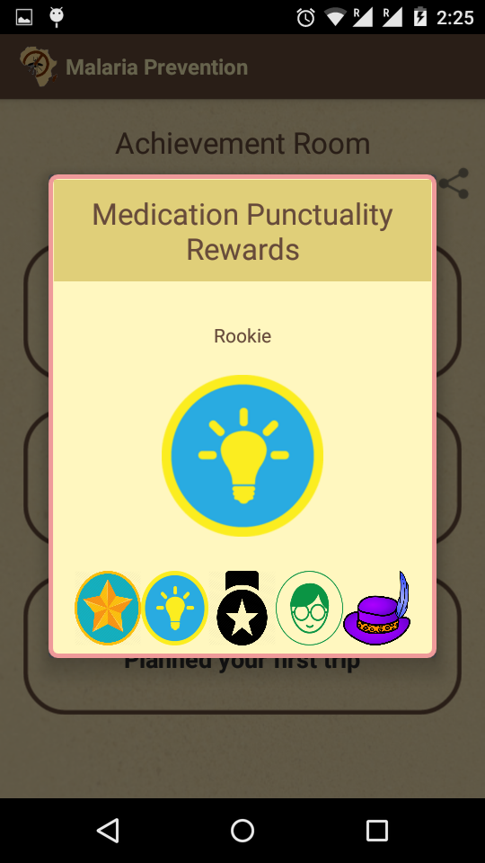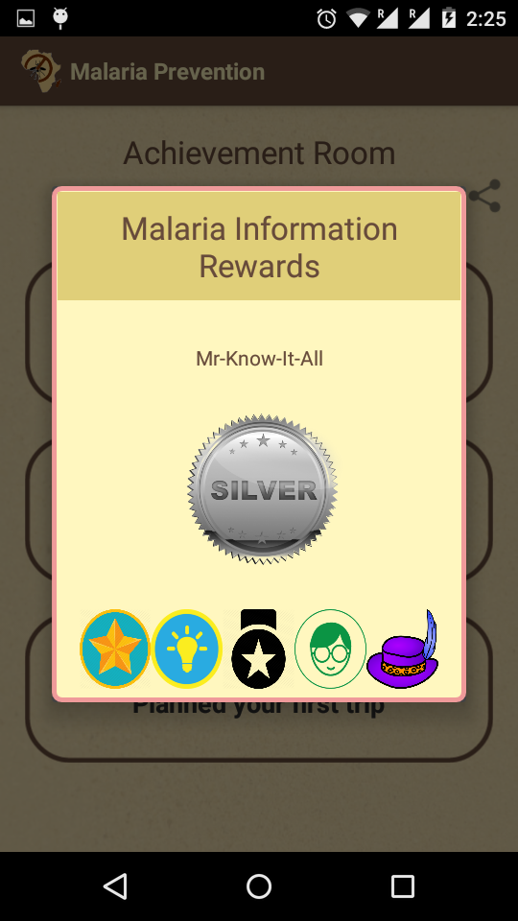

Clicking on the share button lets the user share his/her achievements on social media.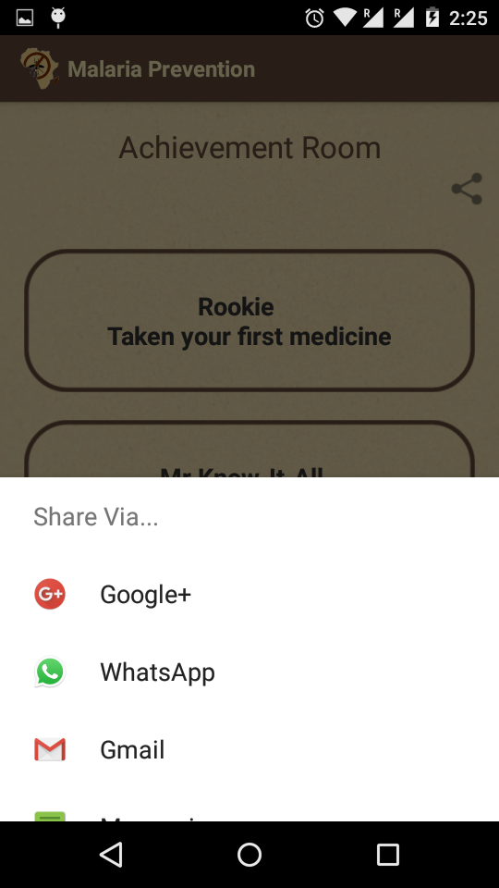

**Mini Games:**

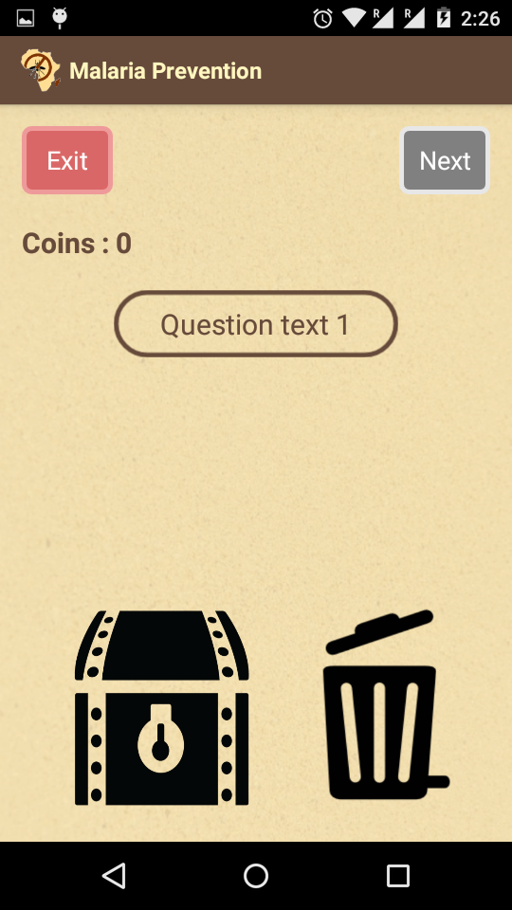

**Myth vs Fact:**

* Given a statement user has to tell whether it is a myth or a fact.
* To make this interactive It has been implemented using a Drag N Drop feature .
* The screen will have 2 boxes, one the ' Trash ' and other will be the ' Locker '.
* The user can drag the statement and drop it into the 'Trash' if it is a myth or put it in the locker if it is a fact.
* User can move to the next question by clicking the button on the top right corner, which becomes active only when user has attempted the current question.
* +1 is given for a correct answer and 0 for wrong answer.
* The user can exit the game anytime using the exit button , his/her score will be recorded and stored automatically.

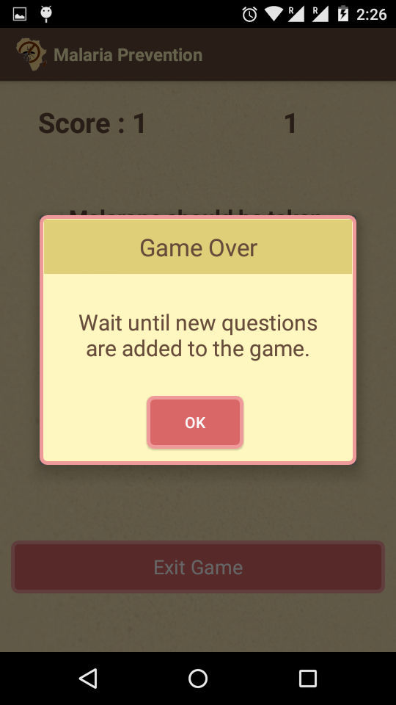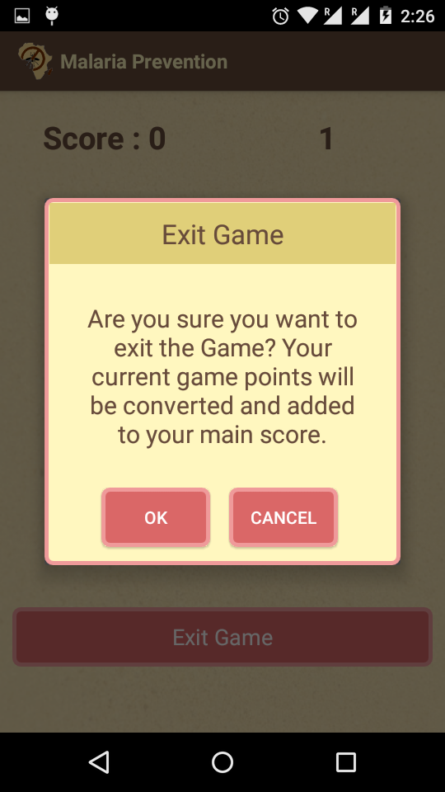

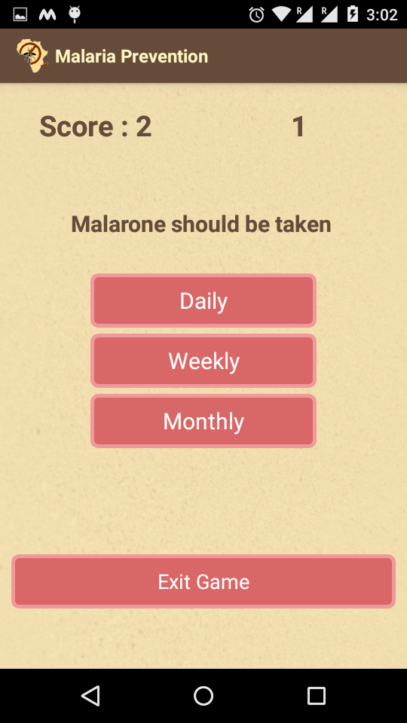

**Rapid Fire:**

* Simple rapid fore quiz game where each question has 3 possible options out of which only 1 is correct.
* User will select the correct option by clicking on it.
* User has 5 seconds to answer, after which game jumps on to the next question.
* Timer for each question is displayed on the top right side of the screen .
* User gets +1 for each correct answer.
* The user can exit the game anytime using the exit button , his/her score will be recorded and stored automatically.

**Medication alert and ordering platform**

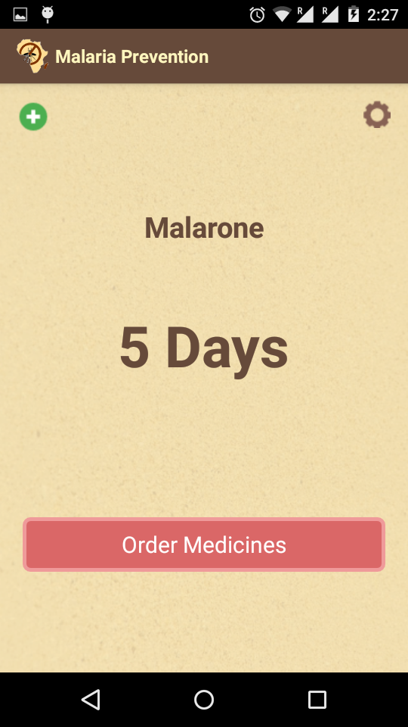

**Alert Platform:**

* The user will be required to enter the amount of medication they have initially.
* Based on the frequency of drug taken the amount of medication left will be calculated and displayed automatically.
* The user can specify the number of days/week , he/she needs to get reminded before the medicine ends. This can be done by using the button on the top right corner on the screen.
* If they amount of medication left is less than the time specified by the user the home page will display an alert message to get a refill as soon as possible.
* If the user gets a refill, he/she can add it by clicking on the add button on the top left of the screen.

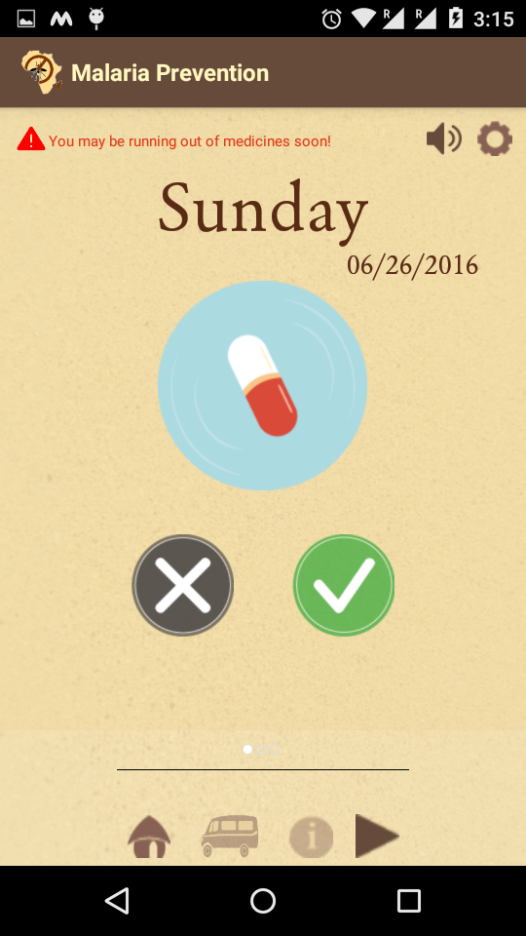

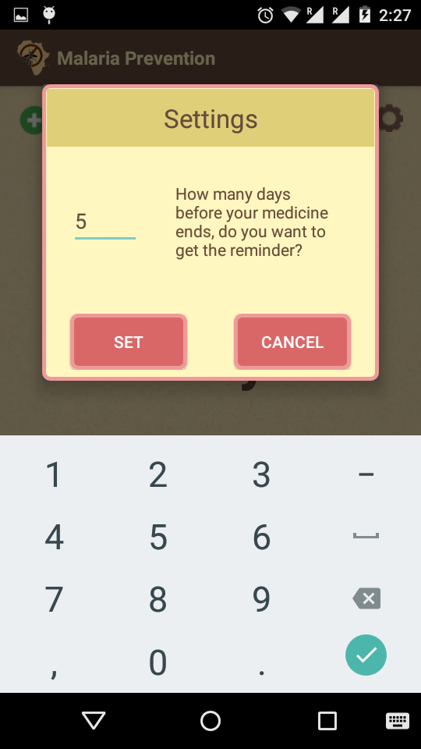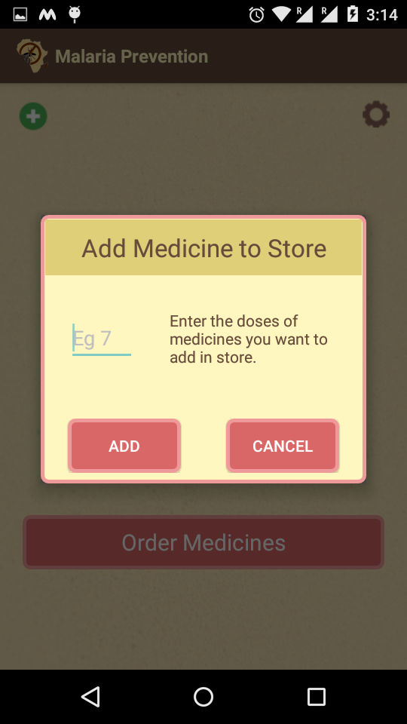

**Ordering Platform**

* Clicking on the 'Order now' on the alert screen one can order medicines via email or via text message.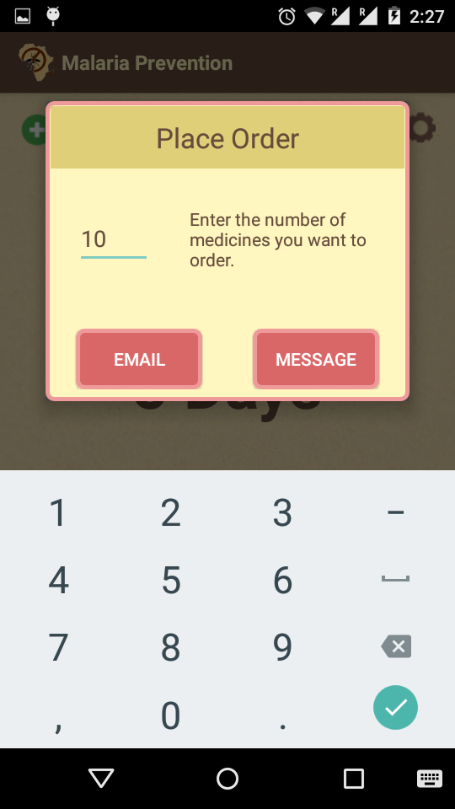
* Only the quantity must be specified, rest all the details will be extracted automatically, and an email/ text msg will be generated and send.

